**1- How many Namespaces exist on the system?**

“kubectl get namespaces”

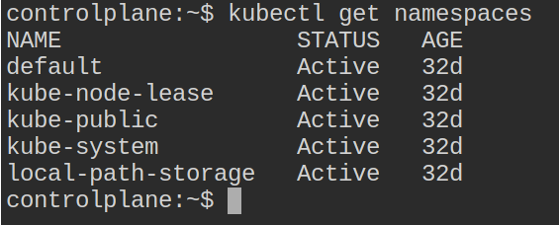

**2- How many pods exist in the kube-system namespace?**

“kubectl get pods -n kube-system”

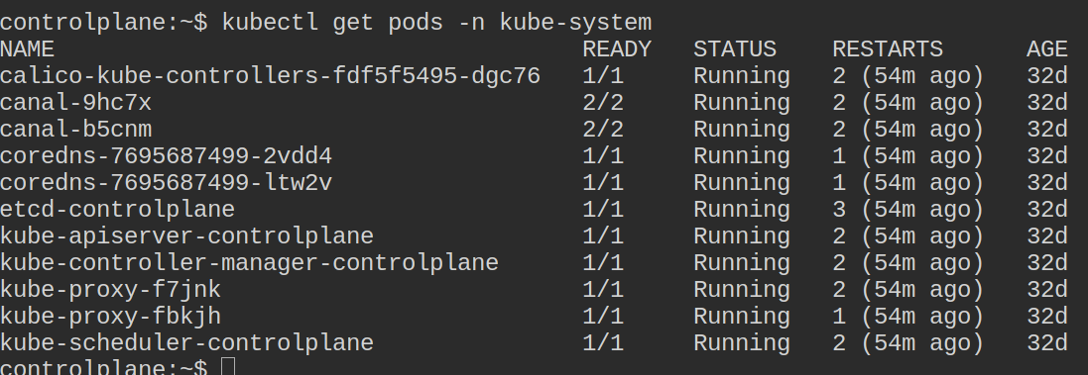

**3- Create a deployment with**

Name: beta

Image: redis

Replicas: 2

Namespace: finance

Resources Requests:

CPU: .5 vcpu

Mem: 1G

Resources Limits:

CPU: 1 vcpu

Mem: 2G

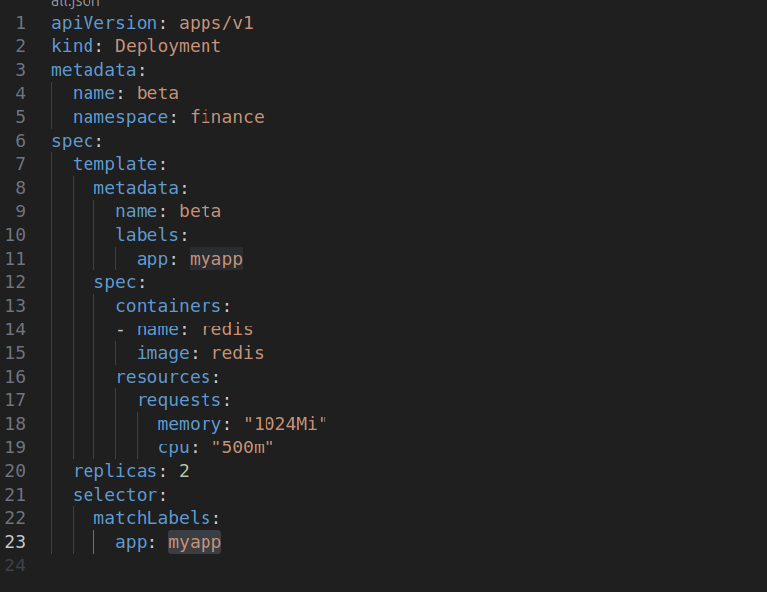

**4- How many Nodes exist on the system?**

“kubectl get nodes”

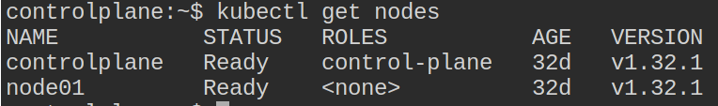

**5- Do you see any taints on master?**

“kubectl describe node kubemaster | grep Taints”

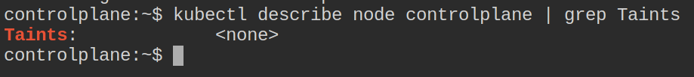

**6- Apply a label color=blue to the master node**

“kubectl edit node controlplane”

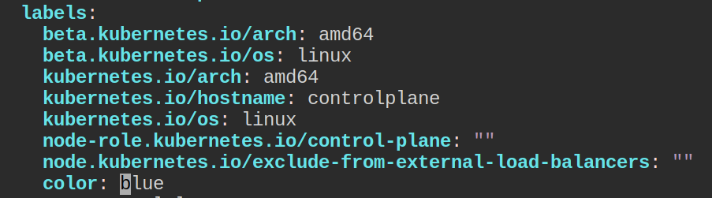

**7- Create a new deployment named blue with the nginx image and 3 replicas**

**Set Node Affinity to the deployment to place the pods on master only**

**NodeAffinity: requiredDuringSchedulingIgnoredDuringExecution**

**Key: color**

**values: blue**

